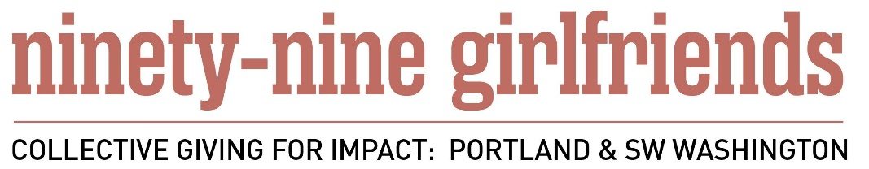

Community Study Teams 2017

Goal: To provide information about key community needs and resources in our focus areas that can guide grant making. A secondary goal of building relationships for 99 girlfriends and getting advice that can provide feedback to us and help shape our thinking.

Activities:
- Attend an initial work session to meet your teammates, learn, organize and discuss
- Join a study team, focused on a content area with 2-3 others to collaborate on research, a report and a presentation. Expect 3-4 meetings with the team. Organize the team to assess your expertise, choose your areas of focus, brainstorm about experts and other local resources, and make research assignments.
- Interview experts to find out about critical needs and emerging issues in each focus area. Experts may include nonprofit leaders, community leaders, academics, and others knowledgeable about both national and regional concerns, trends. Be sure to make appointments in advance, and thank people for their time. Build relationships for yourself and for 99 Girlfriends.
- Collect research about needs and issues from articles, annual reports and websites.
- Synthesize your research in a way that provides coherent context for understanding. This may be based on a framework to be shared by ninety-nine girlfriends advisors Chris Grumm.
- Use the information you obtain through research, interviews and your shared thinking to produce a brief research report per focus area. The report should include:
  - Key areas /issues in this topic area in the US
  - How do we compare to other parts of the country in this topic area?
  - What are the support resources in our region to address these issues?
  - What are we really good at in our region? What are we proud of?
  - In terms of our approach to this topic, what are our region’s Strengths, weaknesses, opportunities and threats?
  - What do we need to get much better at?
  - What are some key trends impacting this area?
  - Where are our greatest needs in this area?
  - What are 3-5 priorities for action--long term and short term?
  - Resources/annotated bibliography with links--where to learn more?
- Prepare a 20-minute presentation to our members that will be part of the June 20th Discovery Forum. Your presentation can be done by an expert, a panel, or members of the team and should include no more than 6 slides regarding your findings. We will provide presentation training.
- Present at the Discovery Forum June 20th.
- Members of your team can be available as advisors as the Grant Review Teams do their work in summer and fall.

Step by Step:
Step 1: Feb, 2017 Teams formed with leaders and advisors identified
Step 2: Feb 27 5:30 Work session orientation meeting at Lisa Adatto’s
Step 3: Feb-Mar Teams make assignment for research: identify experts, white
papers and research reports, interview experts, site visits, If appropriate, identify a subset of issues within the focus area
Step 4:3/31, 4/13 or 4/14 Work session w/ Chris Grumm on ways to synthesize learning
Step 5: Apr 30 DELIVERABLE 1: Written draft of initial scan of issues (using the question list) Emphasis: emerging issues & critical needs
Step 6: May 31 DELIVERABLE 2: Finalize reports/slides for presentations
Step 7: June TBA Work session to practice presentations
Step 8: June 20 DELIVERABLE 3: Present findings at Discovery Forum

